Graphic Design: Traditional to Hybrid
Jessica Crabtree
IT899XA
Emporia State University

Design & Development Report
With a report from the Instructional Design Center at the Flint Hills Technical College, Megan Allen, the Graphic Design Instructor was needing assistance in designing a course for the course GAT 220. The instructor needs assistance in designing a course because of the struggle for the students to retain resources and submit assignments. These struggles were that she was handing out resources to students as paper copies in the classroom, the students were then handing in assignments on paper or through e-mail. Therefore, she needs a class to use to make resources easily accessible and submitting assignments to take her face-to-face class to a hybrid class.
Design and Development
Performance Objectives
Once the course is designed the students in the GAT 220 class will be able to meet the following performance objectives:
- Students will be able to access resources from the learning management system, Moodle, that are needed for GAT 220 with 100% accuracy.
- Students will be able to submit assignments on the learning management system of Moodle with 100% accuracy.
Description of Content
The instructional materials have been shared from the instructor to help design the course on Moodle. The needs of the instructor, who reported to the Instructional Design Center Director when a survey was sent out to the faculty, showed that there was a need for the GAT 220 class to be in a hybrid course set up to meet the needs of the students. This will benefit the students to have better access to resources and to easily submit assignments.
There will be several types of instructional materials present in the class. For the resources of the students there will be a copy of the student notes pages posted to the class. These notes will be in the form of a PDF and a Microsoft Word Document. Once the lecture has been concluded the instructor will also be able to open up the PowerPoint presentation that is used in class for students who missed class to use as their resource for their notes and reference when completing assignments. Along with notes being available for students there will also be resources that they use to complete assignments. This will include worksheets that are covered and completed in class. The students will then submit those worksheets and assignments to Moodle. Therefore, the instructional materials and how they submit them will be available to them on Moodle.
The following is the course thus far in the designing and development stages. This project did change during the week of March 16th with the COVID-19 and closure of the Flint Hills Technical College buildings. The design and development process were a little bit faster than planned and the introduction module was created and then the instructor needed the Lesson 1 and Lesson 2 of Unit 2 created to begin classes on March 23rd. I feel this gave me an even better perspective of what an instructional designer faces with this occurrence.
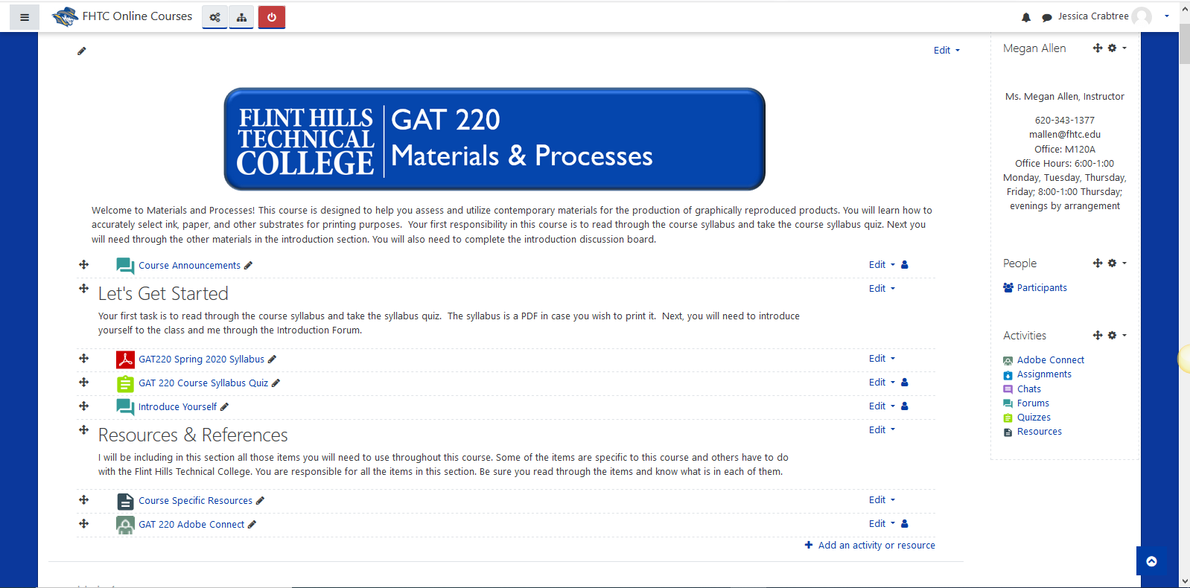

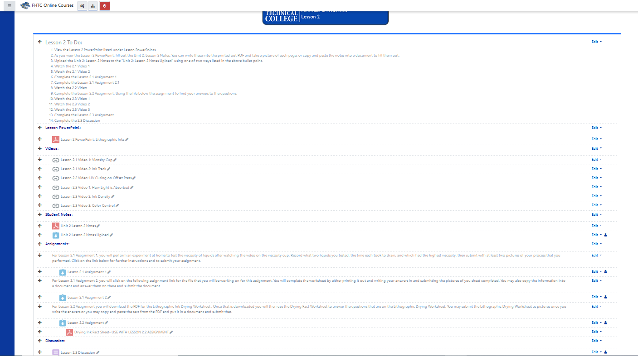
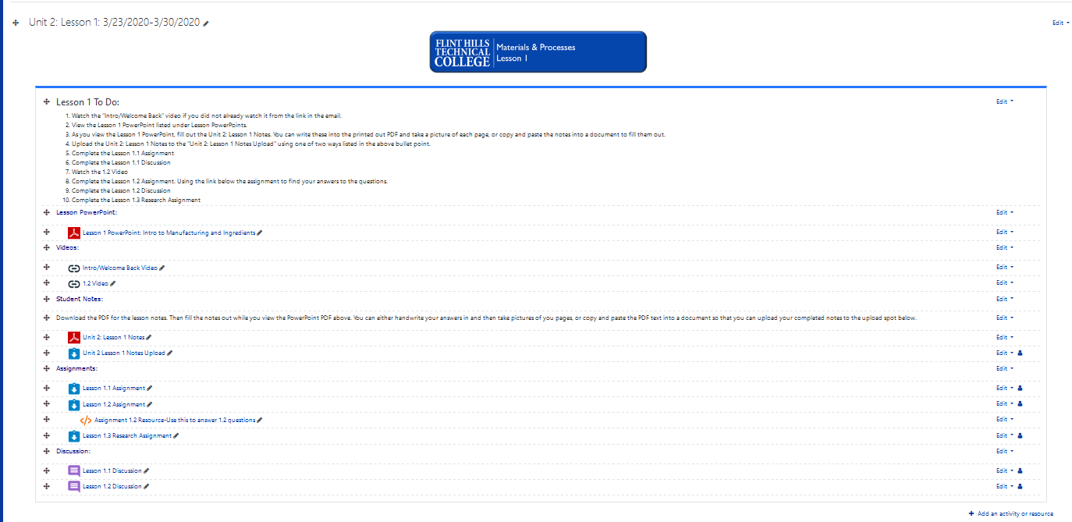

Instructional methods include in-class lectures, discussions, and demonstration. The lecture and discussions will be completed within class. The media that accompanies these lectures and discussions will be given to students through Moodle. These discussions will be given through Moodle in the form of forums. Students can then interact and ask each other questions while responding to on another. The instructor can choose different types of discussion boards to accommodate the type of forum needed. The instructor also uses demonstration in class to help students get started on assignments that they will access on Moodle.
The media that will be used to communicate these instructional methods are in several different formats. There will be lecture slides given to students through Moodle of the file type Microsoft PowerPoint and also PDF. This will encompass the lecture and discussion parts of the face-to-face part of the class. Worksheets given in Microsoft Word and PDF form will also be given to students on Moodle for students to access and then submit to Moodle.

Pilot Study Program
The pilot group will consist of 23 members. These are the students who are currently enrolled in GAT 220. Each member will review the Moodle course that is created. They will access the resources and submit assignments to the links provided. These members will complete the evaluation form. This pilot program was plan to be implemented on April 6th , however, with COVID-19 and the school buildings closing, this course is now being used with design and development stage happen quicker than normal. The introduction module was designed and then the instructor needed Lesson 1 and Lesson 2 in Unit 2 created. These plans changed the week of March 16th and were implemented with Lesson 1 and Lesson 2 ready for students on March 23rd. This pilot program is still a pilot as they will still complete an evaluation and help to improve modules for future use. The members will have one week, five business days, to complete the evaluation. There will also be a pilot test that occurs with two students. I will use Adobe Connect to bring in the students and have them share their screens with me. I will then ask the students to complete four different tasks to show that they have met the objectives.
Evaluation Plan
The evaluation will be given through a Google Form for students to complete. When the form is complete it will give me statistical feedback on how the members responses. This will make it efficient to gather the data and a cost-efficient way as well. This survey will be based off of what George M. Piskurich has identified as important items to evaluate when working with a trainee’s reaction to a course in Rapid Instructional Design (2006). The full survey is attached. Any feedback that is given will be used to improve the course and the accessibility of the course. Other evaluations will be done by the Instructional Design Center director with their form that is based on the Quality Matters evaluation.
The pilot test with two students was also used. They were brought in through an Adobe Connect session and were asked to verbally and visually complete four tasks. Both students completed all four tasks successfully. You can view the tasks that they were asked to complete below.
Conclusion
The proposed class design will provide students the access to their class materials more easily. The instructor reaching out to the Instructional Design Center Director showed that there was a need to create the class as a hybrid set-up for the benefit of the students. I have begun designing the class for GAT 220. To move forward I will continue to receive feedback from the instructor through email and adobe connect sessions to finish the class setup.

Attachment 1
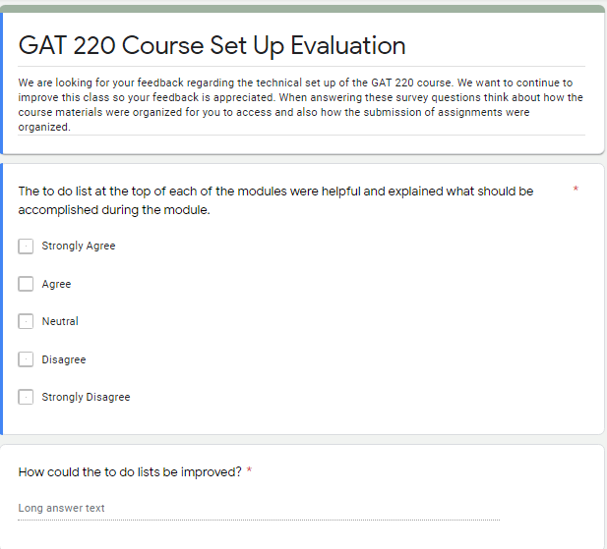
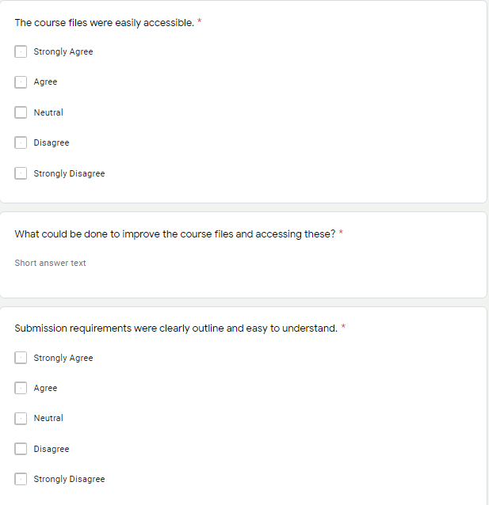

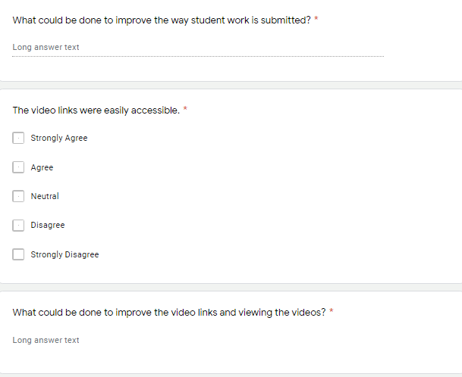

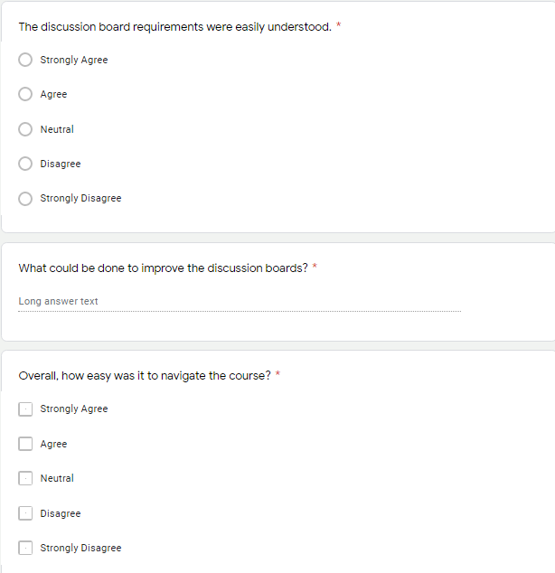

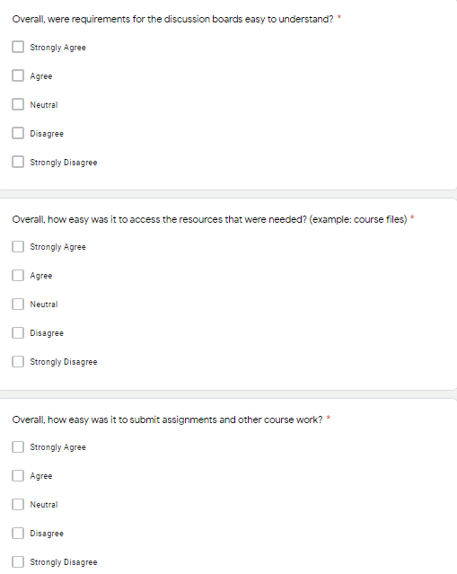

Attachment 2

The following are the tasks completed by the two students in the pilot test:

- Show me how you open up the file named Lesson 3 PowerPoint in Unit 2, Lesson 3.3-3.4 module.
- Can you show me and explain how you open the video for Lesson 3.3?
- Show me how you would submit a file for your student notes to be graded.
- Show me how you would access Lesson 3.3 discussion board. How would you reply to a classmate?
References

Piskurich, G.. (2006). Rapid Instructional Design: Learning ID Fast and Right. Second Edition. Retrieved from: http://elearning.fit.hcmup.edu.vn/~longld/References%20for%20TeachingMethod&EduTechnology%20%20Tai%20lieu%20PPDH%20&%20Cong%20Nghe%20Day%20Hoc/(Book)%20-%20Sach%20tham%20khao%20-%20Technologyenhanced%20Learning%20(TEL)/2006%20G.M.Piskurich%20%20Rapid%20Instructional%20Design.pdf

