Moodle 101:

Hello! This will be a great resource for you to help you in navigating your Moodle site for your classes for the remainder of the school year. Please read each section carefully and refer back to this document when needed!

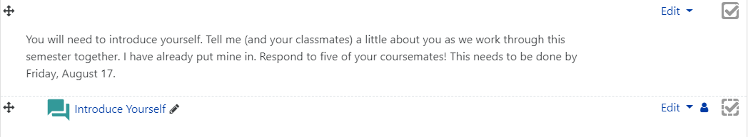
- LABELS ARE YOUR FRIEND!! Be sure that you read everything that is in the modules on Moodle! There will be important directions and information that your instructor has put there to help you navigate the course. You instructor may have also put directions into an assignment once you click on it. Be sure to stay aware. An example of what a label might consist of is below.

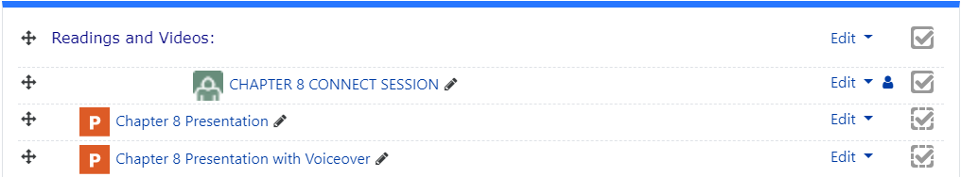
- POWERPOINTS: There will be presentations and videos that your instructor will post for you to go through. It is VERY IMPORTANT that you carefully watch the PowerPoints and/or videos. These will be the resources that help you learn the content and take the form of the lecture that you would receive in the classroom. You can download the PowerPoint and/or the video and then view it. If there is a link to the video-WATCH IT! You may also have a PowerPoint with voice over option listed if your instructor has made that an option. If you have that option you will hear your instructor talk through the PowerPoint as you watch it. An example of what this looks like when listed in a module is below.

- CONNECT SESSIONS: You will also notice in the picture above that there is also a link to a “chapter 8 connect session”. These are sessions that your instructor has set up as another way to communicate with you. There will be a time for those sessions that you can join and then be able to in real time with your instructor. If you instructor informs you that there will be a connect session at a certain time that will be the link that you are looking for.

- FILES: In your Moodle class there may be files that you need to download at some point. This may be files that help you with an assignment or it might be your actual assignment that you need to complete. You will click on the file and download it and then be able to save it and work on it.

- UPLOADING ASSIGNMENTS: Within your Moodle class there will be a spot to upload assignment files to so that your instructor can grade the assignment. It is important that you submit your files to this spot so that the instructor can grade. You will select the upload spot for the assignment and then go through the steps to submit the assignment. Once you submit the assignment your instructor can then grade it. An example of what an assignment upload spot looks like is below.

- DISCUSSIONS: There will also be opportunities for you to complete discussion boards and interact with your classmates! There will be directions for the discussion and what you should be discussing at the top once you click on the discussion link in the module. Follow the directions and post your initial post. You can also click on the reply button on other student’s post to respond back to other students. An example of what a discussion spot looks like is below.


- QUIZZES: You will also have quizzes or tests that are listed in the module that you will need to complete. There will be a multitude of different questions that you may come across that your instructor has added. There is multiple choice, true/false, essay, short answer, and matching. An example of what a quiz spot looks like is below.


