Graphic Design: Traditional to Hybrid
Jessica Crabtree
IT899XA
Emporia State University

Graphic Design: Traditional to Hybrid Final Report
Introduction
This project has been based around the Graphic Design class called Materials and Processes. The focus of this course that I have been designing is for students to assess and utilize contemporary materials for the production of graphically reproduced products. The materials that are covered in the course are paper, other substrates, and then ink as well. Students progressing through the class should be able to select inks for printing production and also select the correct paper for printing production. The students in this course are second year students in the Graphic Design program.
Megan Allen, the instructor of the Materials and Processes class wanted assistance in setting up a class on their learning management system of Moodle. This project started to take this class from a traditional face-to-face class, to a hybrid class. With the pandemic of COVID-19 this quickly changed into a fully online class for this year. Ms. Allen needed assistance in having an effective set up in her course that will be easy for students to navigate. She also needed assistance in organizing the materials in an effective way that students can use outside of class time and during class time.
The major push in education is using technology. Having technology integrated into the classroom, having online courses, or having hybrid courses. There are endless possibilities with technology, and the generations that we have in our classroom are used to using technology in their everyday lives. Ms. Allen, at the Flint Hills Technical College would like to have more of the resources that she offers to the students available online. With the high demand of Ms. Allen’s time being put to teaching, and inexperience in setting up online courses Ms. Allen needed help with taking this traditional class and moving it forward.
At the start of this project, during class, Ms. Allen handed out paper copies of resources, and students turned in their assignments to the instructor through a paper turn in or by email. The problem that needed to be addressed in this project was putting the resources that Ms. Allen gives the students on Moodle for them to access anytime and for work to go paperless. Assignments also need to be placed on their learning management system for a seamless informative and turn-in process for Ms. Allen and the students. Again, this same problem held but it did lead to more extensive design and development with the onset of COVID-19 in early March.
Analysis
It was determined in the analysis phase, according to the college’s plan for their online integration, the class did need to be updated to bring in the technology piece of Moodle. This plan was with the instructional design center, administration, and an Online Subcommittee made up of instructors who oversee the online process. They have a goal for all faculty to incorporate technology and effectively utilize Moodle in their classes. All of this analysis showed that changes needed to be made to take this traditional class to a hybrid class and then to a fully online course as a result of COVD-19. By taking this class to a hybrid class for next year, and a fully online class this school year, it would be up to date with goals of the instructional design center, using their rubric for evaluation, and administration. When analyzed the learners in this class can be put into distinct generational groups of Generation Z and Millennials. Therefore, they are students who are used to having technology at their fingertips and have questions answered quickly.

Design Decisions & Strategies
The instructional strategy will be having this course as a fully online course now and then as a hybrid course in the future. By having the course as a fully functioning online course this school year, and hybrid course next school year, it will help the students in obtaining course materials more conveniently and timelier for better student learning. The students have had more opportunities to have the resources and assignments at their fingertips and be more motivated to complete them. Ms. Allen has also had more opportunities to add resources easily and grade assignments, which has helped her also incorporate more instructional strategies into their teaching and causing her more motivation as well.
The principles shown in this project are from psychologist Gagnes Conditions of Learning where he defines nine events that represent the external instructional activities (as cited in Dick, Carey, and Carey, 2015, p. 174). These nine events are; “1. Gaining attention, 2. Informing learner of the objective, 3. Stimulating recall of prerequisite learning, 4. Presenting the stimulus material, 5. Providing learning guidance, 6. Electing the performance, 7. Providing feedback about performance correctness, 8. Assessing the performance, 9. Enhancing retention and transfer”. All of these principles have been shown when the instructor has had the course online and then, will be shown, when it is a future hybrid course. These were important to remember as we designed the course because they were the “why” for creating and designing this course. The course was designed so these nine events are being met.
There were several factors of motivation in this project. The motivation for the instructor came from the goal of the instructional design center and administration in the college is to have Moodle utilized in all courses in some form. That was the motivation for Ms. Allen to learn and utilize Moodle. Once she was informed of my plan and was more familiar with Moodle through our project, she has seen how Moodle will make resources easily accessible to her, just like they are for the students. Ms. Allen also had motivation from the fact that the grading of assignments was more streamlined than they were before in her classes. The feedback and grading system is easier to use and easier to access for Ms. Allen.
Creating the online learning opportunity for students has made the materials more accessible to students and, therefore, has led to a higher level of motivation. With the generation of Millennials and Generation Z in the classroom, this has seemed appealing to the students. These generations are both groups that enjoy hands-on activities and also enjoy the integration of technology. The more an instructor can integrate technology the more this generation is eager to engage and learn more. According to Ryan Jenkins, next-generation speaker, “Generation Z doesn’t know a world where a smart device has been outside of arm’s reach.” (Jenkins, n.d.) He also went on to say, “Having 24/7 access to the world’s information via a super computer in their pocket has rewired how Generation Z problems-solves, networks, communicates, learns, buys, and ultimately how they will show up in the workplace.” (Jenkins, n.d.)
With the information we know about the generations in this class it was important to take this class into using more technology. The students will relate to having this class online and using more technology will make them feel more comfortable. With the instructional strategies presented by using online notes, videos, and Adobe Connect the students are learning through technology integration. This generation also enjoys engaging with others through technology, which is why it was also important to include forums for the students to respond to, and also, interact with each other in.

Pilot Implementation
The implementation of this course changed drastically with the COVID-19 Pandemic. I feel though that the drastic change made the project stronger. During March when school buildings closed, the class went online. I was able to put the project into use quicker. Therefore, the implementation of this course fully happened during this school year instead of it just being a pilot test at the end of the year.
Luckily, Ms. Allen and I had completed the development and design of the course. Therefore, it was a smooth transition to put the course online. We did have to implement a few more items into the course due to the circumstances, but the design and development that we had completed held. Although we were not able to conduct the pilot testing before the entire group had access, we did complete a pilot testing to make changes in the process. The pilot testing was conducted with two students and the results are further described below in evaluation.
Reflection on Evaluation
When designing the evaluation, I wanted to receive feedback concerning objectives being adequately met and the overall course design fitting the students’ needs. Using the evaluation, I wanted to see what changes needed to be made to improve the course and what other training needed to be done.
The first piece of the evaluation was a survey completed by the classroom students determining their progress through the class. This survey asked questions to verify they knew how to access an assignment or file. It also requested if they knew how to access a discussion board and participate in that discussion successfully. The survey asked them if the videos were accessible for them and how the way they were submitting their work. All of the questions were asked on a Likert scale with students agreeing or disagreeing with the question being asked. Along with each Likert scale question, an open-ended question followed. Open-ended questions such as, “What could be done to improve the way that the student work is submitted?” These provided more complete data because even if students agreed the work was easy to submit, they could provide their insight freely for me. By giving them the open-ended questions after every Likert scale question, I was then able to update the course with suggestions the students gave to help them be even more successful. Graphs and responses to some of these survey questions are below in Appendix A.
My pilot testing was also an integral tool in the evaluation process. Two students were present for the pilot testing. They were individually brought in with an Adobe Connect session to complete the pilot testing since we were unable to meet face-to-face during this time. The students were given presenter rights during this session and shared their screens so I was able to view as they completed the tasks. These two participants of the pilot test were given multiple tasks to complete in the course. As they completed a task, I was able to see their screens and they also verbally explained what they were doing. During this virtual conference, students were given tasks such as, “Show me how you open up the file named Lesson 3 PowerPoint in Unit 2, Lesson 3.3-3.4 module.” “Can you show me and explain how you open the video for Lesson 3.3?” “Show me how you would submit a file for your student notes to be graded.” “Show me how you would access Lesson 3.3 discussion board. How would you reply to a classmate?” The students both completed these tasks successfully and the students’ responses are in Appendix B.
Throughout this course there has been a training solution in place for students. This training solution was developed using a beginning analysis the instructor and myself considered were potential struggles the students would need to overcome. The training solution has been changed and updated through the class design, the implementation, and pilot testing.
For the training solution, I decided to compose a LiveBinder with a few resources for students. I felt a LiveBinder was a great way for students to have access to several pieces of training in one place. This resource was also helpful for the instructor to use as well to look for ways to integrate technology apps into the online platform. However, not only did the students and instructors of this class use this, but the instructors throughout the entire college were also given the resources I created. The first item in this LiveBinder is a document named Moodle 101. This document gives students an overview of all of the items and tasks they may encounter when they are in the class. Each of the tasks and items shows a picture of what the icon for that task would look like, what the task is, and explains what the instructor expects of them. The next item is information about screen-cast-o-matic. This a great tool if the students were needing to submit videos of them completing tasks or answering questions. It was also a tool they had not used often so we felt including it as part of the training solution was important. For the last item, the possibilities of how the students could use it are endless. This item is another LiveBinder I was the co-creator of which includes all different types of technology tools to help with communication, creativity, reviews, creating video, and much more. This is a resource students could reference when needing various tools to use for different assignments.
Conclusion
I was overwhelmed when starting this project with how many pieces needed to go together to take a traditional face-to-face class into a hybrid class. Ms. Allen was great to work with and we were able to get a functioning design when developing the class. Once we had the design, I had started to create what I had proposed, and what she had approved for her class. Then in early March the COVID-19 Pandemic started to occur, as I have stated previously. At first, I thought the closure of school buildings was going to extremely change the whole class design we had decided upon, when in fact it did not. We had to add in several items to make it an adequate and fully developed online learning environment for the students since there would be not “face-to-face” time once the school building closed.
With the obstacle of COVID-19, I think it made this project more meaningful and showed me the true job of an instructional designer. The first characteristic it showed me was flexibility. When this started to occur, I immediately contacted Ms. Allen and we began to review what we had already designed and figured out where to add more content or videos. I also learned how important evaluation and pilot testing is. I was consistently thinking of the learner when designing the class and what would make it easier for them. Their feedback and comments were vital in making it a success.
I enjoyed working on this project and feel it gave me a glimpse into an instructional designer’s job. I feel the project was successful and despite the negative time we are in currently, there was something good that evolved.

References
Dick, W., Carey, L., & Carey, J. (2015). The systematic design of instruction. Boston, MA. Pearson.
Jenkins. R. (n.d.). How generation Z uses technology and social media. Retrieved from https://blog.ryan-jenkins.com/how-generation-z-uses-technology-and-social-media

Appendix A
Below you will find some of the questions that were asked on the survey that were given to the students. I received 15 responses to this survey that then I could use to improve the class for future use.
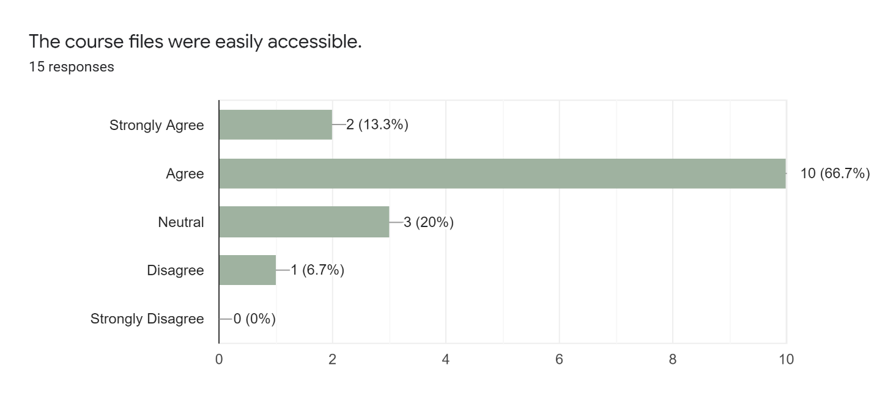
What could be done to improve the course files and accessing these?
- If the files were sent as Google docs instead of pdf's.
- what could be better is that when we download them we can write to them
- I like the way they were set up.
- I don't believe there needs to be any improvements.
- The course files are easily accessible. I believe they just fine as how they are set up as.
- Not that i can think of
- Provide upcoming week assignments in case certain students need to finish those a little early due to anything upcoming in their current life situation.
- Could be a bit more organized
- I don't have a problem with anything.
- Homework sheets given as PDFs
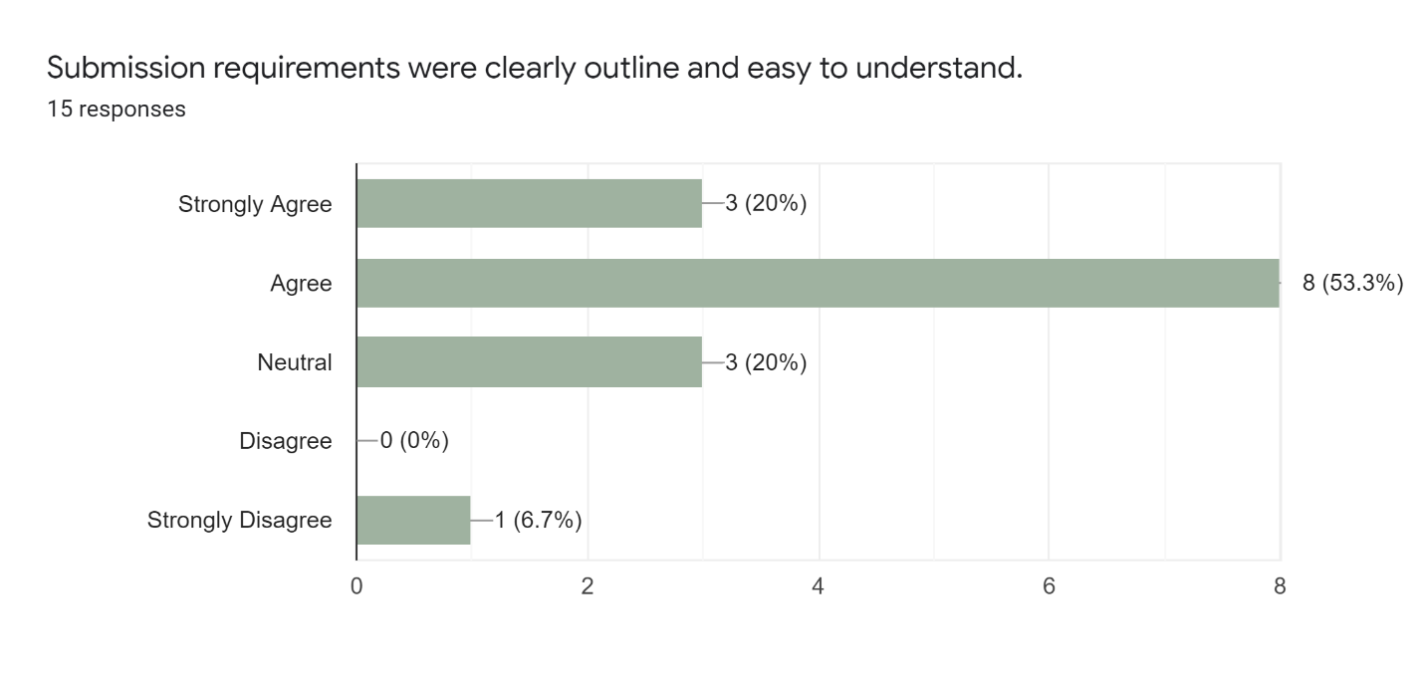

What could be done to improve the way student work is submitted?
- It would be helpful to be able to submit Google docs as well as pdf's.
- I think that is fine like that
- Many of the assignments need just a sentence or two answers. It is annoying to have to open up and entire document and type it out. My other class uses a different submissive layout and it allows us to type directly into it.
- I don't believe there needs to be any improvements.
- The way to turn in student work is perfectly fine how it is and it is easy to do. I don't know know if there is a way to improve it.
- Nothing
- This is already being fixed but put the deadlines at the end of the week than throughout the week.
- Nothing they were very well executed
- I don't have anything that can be improved.
- Nothing.

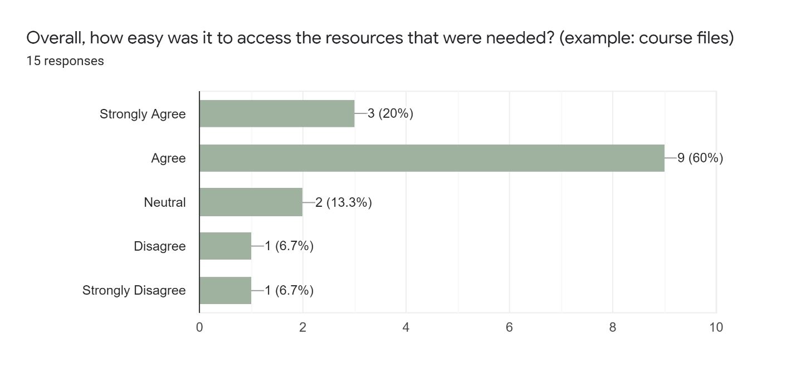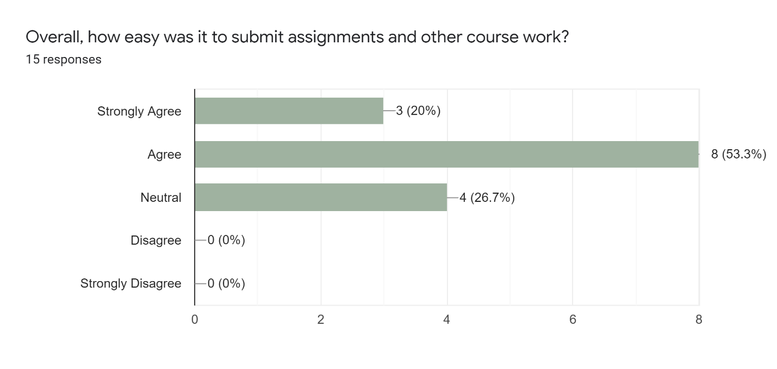

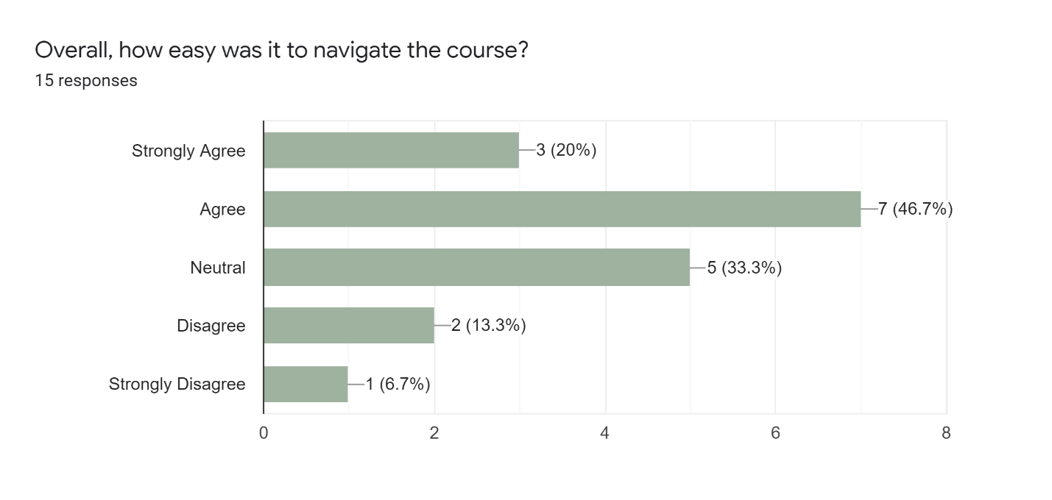

Appendix B
The following shows the answers given in the pilot test group by two students.
- Show me how you would access the Lesson 3 PowerPoint file in the Unit 2: Lesson 3.3-3.4 Module.

Student 1
Showing me their screen as they complete it. “You would need to scroll down to find the Unit 2: Lesson 3.3-3.4 module. Once you are in the right module you would then select the PDF named Lesson 3 PowerPoint and click it. Once you click it then you will see it open in another window. You can fill the notes out then.”

Student 2
Showing me their screen as they complete it. “I would scroll down and find the Lesson 3.3-3.4 module and then select PowerPoint file at the top of the module. Once I click on it the file will open in another window for me to work in.”

- Open the video name Lesson 3.3 Video

Student 1
Showing me their screen as they complete it. “For the lesson 3.3 video I would need to find the 3.3 module so I would scroll down and find the module. Within the module I would then select the URL link to the video. Once I click on it the video will pop up in another window and then I will be able to view it.”

Student 2
Showing me their screen as they complete it. I would first find the lesson 3.3 module. When I scroll down and find the module, I then click on the link that says Lesson 3.3 Video. Once I click on the link the video pops up and I can view it.

- Take me through the steps that you would go through when submitting a file for your student notes assignment.

Student 1
Showing me their screen as they complete it. I would first fill out my notes and I copy from the PDF into a Google Doc to fill out my notes file. Once I have them filled out in a Google Doc and I then save them as a Word Document. When they are saved as a document I then come to Moodle and find the Lesson 3 module and look for the icon for an assignment so I know to upload it to that link. I click on the link and then say submit. It then lets me upload my file and I can click on submit assignment.

Student 2
Showing me their screen as they complete it. Once I have my notes filled out, I go back to Moodle and find the Lesson 3 Notes upload spot. Once I click on that I can submit them by selecting submit assignment and then uploading my file and clicking submit.

- Show me how you would access the Lesson 3.3 Discussion. How would you then reply to a classmate’s post?

Student 1
Showing me their screen as they complete it. I would find the Lesson 3.3 module and then scroll to the bottom where our discussion boards are always located. I select the Lesson 3.3 discussion. Once it opens then I can click on reply to reply initially to the post. I can then see everyone who as replied to the post and see how many people have replied to each person. I can click on the number of replies and it will show me that persons post. Once I am in their post I can click on reply and type in my response to them and click save.

Student 2
Showing me their screen as they complete it. I first find the Lesson 3.3 discussion board in the Lesson 3.3-3.4 module. Once I find it at the bottom of the module, I think click on it and it will show me what we are supposed to discuss. I can click on reply and it will take me to where I can post my reply. I click save and it will post it. To answer a classmates I can click on their name or this number that shows the number of replies that they have to their posts and then reply to them.

